3. Arrays
3.1 Introduction to Array
An array in C# is a group of data of same datatype that are referred by a common name. A single data of an array is referred as element of an array. The elements of an array are stored in a contiguous memory location. Array stores a group of related data items under a single variable name, making it easier to manage and manipulate collections of data. Each elements in an array is accessed using index and the index starts from 0 for the first element.
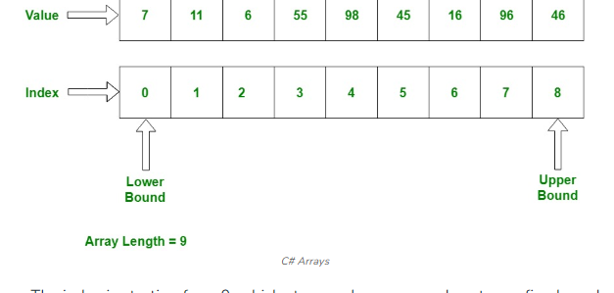

The characteristics and concepts related to arrays are
1. Declaration and Initialization
2. Accessing Elements
3. length and size
4. Array Initialization
5. Multidimensional Array
6. Jagged Array

Array can contain primitive data types as well as objects of class depending on the definition of an array. Whenever use primitive data types , the actual values have to be stored in contiguous memory locations. In case of object of class, the actual objects are stored in heap segment.

3.2 Declaration and Initialization of Array
In C#, you can declare and initialize an array in several ways , depending on your requirement.
- Declare and Initialize an Array with a specified Size:
By specifying its datatype, name, and size using the new keyword.
Syntax:
<Data Type>[] Name_Array = new Datatype[length];
For example
Int[] numbers = new int[];
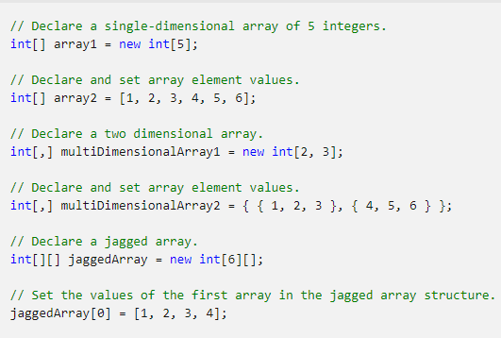
Single Dimensional Array
A single-dimensional array is a sequence of like elements. You access an element via its index. The index is its ordinal position in the sequence. The first element in the array is at index 0. You create a single-dimensional array using the new operator specifying the array element type and the number of elements.
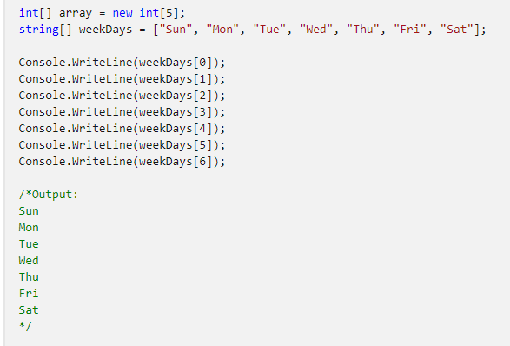

class ArrayExample
{
static void DisplayArray(string[] arr) => Console.WriteLine(string.Join(" ", arr));

// Change the array by reversing its elements.
static void ChangeArray(string[] arr) => Array.Reverse(arr);

static void ChangeArrayElements(string[] arr)
{
// Change the value of the first three array elements.
arr[0] = "Mon";
arr[1] = "Wed";
arr[2] = "Fri";
}

static void Main()
{
// Declare and initialize an array.
string[] weekDays = ["Sun", "Mon", "Tue", "Wed", "Thu", "Fri", "Sat"];
// Display the array elements.
DisplayArray(weekDays);
Console.WriteLine();

// Reverse the array.
ChangeArray(weekDays);
// Display the array again to verify that it stays reversed.
Console.WriteLine("Array weekDays after the call to ChangeArray:");
DisplayArray(weekDays);
Console.WriteLine();

// Assign new values to individual array elements.
ChangeArrayElements(weekDays);
// Display the array again to verify that it has changed.
Console.WriteLine("Array weekDays after the call to ChangeArrayElements:");
DisplayArray(weekDays);
}
}
// The example displays the following output:
// Sun Mon Tue Wed Thu Fri Sat
//
// Array weekDays after the call to ChangeArray:
// Sat Fri Thu Wed Tue Mon Sun
//
// Array weekDays after the call to ChangeArrayElements:
// Mon Wed Fri Wed Tue Mon Sun
Multidimensional Array
Arrays can have more than one dimension. For example, the following declarations create four arrays: two have two dimensions, two have three dimensions. The first two declarations declare the length of each dimension, but don't initialize the values of the array. The second two declarations use an initializer to set the values of each element in the multidimensional array.
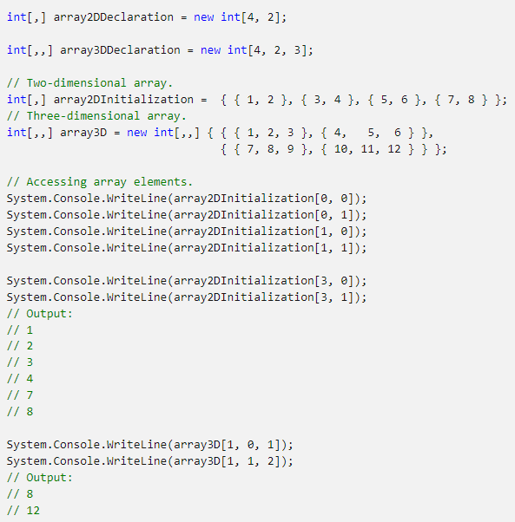

Rectangular Arrays (Two-Dimensional Arrays)
Rectangular arrays, also known as two-dimensional arrays, are multi-dimensional arrays that have a fixed size for each dimension. They are often used to represent data in a tabular or grid-like format, such as matrices or tables. Rectangular arrays have a regular, rectangle shape, meaning that all rows have the same number of columns. You can think of them grid where each cell contains a value.

Here's how to declare, initialize, and work with rectangular arrays:

Declaration and Initialization
You can declare and initialize a rectangular array using the following syntax:
data_type[,] array_name = new data_type[rows, columns):
data type: Specifies the data type of the elements in the array.
array name: The name you want to give to the array,
rows: The number of rows in the array.
columns: The number of columns in the array.
For example, to create a 3x4 integer array:

int[] matrix = new int[3, 4];

Accessing Elements
You can access individual elements in a rectangular array using two indices one for the and one for the column inside square brackets. The indices are zero-based, meaning the row and column have an index of 0.
Matrix[0,0] = 1;
Int value = matrix[1,2]
Iterating through a Rectangular Array

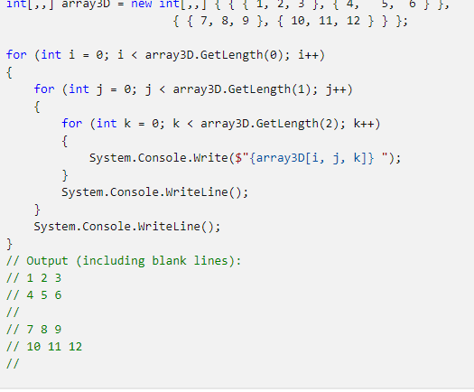

Jagged Arrays
Jagged arrays, also known as arrays of arrays, are multi-dimensional arrays in C# where each element is itself an array. Unlike rectangular arrays, jagged arrays allow each subarray to have a different length. They are more flexible and are used when you need an irregular or ragged structure, such as a collection of rows with varying numbers of columns.
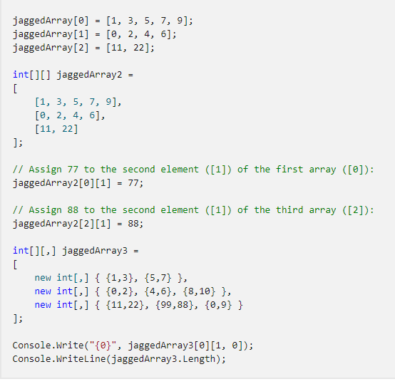

Iterating Through a Jagged array:
You can use nested loops to iterate through all the elements of a jagged array. Here's an example using nested for loops to print the elements:
for (int row= 0; row < jaggedArray.Length; row++){
for (int col=0; col <jaggedArray[row].Length; col++){
}
Console.Write(jaggedArray[row][col] + "\t"); // Print the element at (row, col)
}
Console.WriteLine(); // Move to the next row
}
Properties and Methods:
Jagged arrays don't have a built-in property like Length to get the number of rows or columns. You need to use Length for the outer array and Length for each sub-array to determine their lengths.
Jagged arrays are suitable when you need a flexible data structure with varying sizes for different rows or when you want to work with collections of data that don't conform to a regular grid structure. They provide the flexibility to manage irregular or dynamically sized data.

param arrays
In C#, a parameter array, often referred to as params, allows you to pass a variable number of arguments of the same data type to a method. This feature is useful when you don't know in advance how many arguments will be passed to a method. The params keyword enables you to specify a parameter that acts as an array and allows you to pass any number of values for that parameter

Here's how to use parameter arrays (params) in C#:
Syntax for Declaring a Parameter Array

return type MethodName(params data_type[] parameterName){
#Method implementation
}
- return type: The data type that the method returns.
- MethodName: The name of the method.
- data type: The data type of the elements in the parameter array.
- parameterName: The name of the parameter array declared with the params keyword.

Example
public int Sum(params int[] numbers)
{
int sum=0;
foreach (int num in numbers)
{
Sum += num.
}
return sum;
}

In this example, the Sum method takes a parameter array named numbers of type int. You can all this method with any number of integer arguments, and they will be treated as elements of an array within the method.

Calling a method with a parameter Array
When calling a method that uses a parameter array, you can pass a variable numbers of arguments, and C# will automatically package those arguments into an array for you.

Int result = Sum(1, 2, 3, 4, 5); //passing multiple arguments

Important considerations
- A method can have only one params parameter, as it must be the last parameter in the methods parameter list.
using System;
class Program
{
static void DisplayNumbers(string message, int count, params int[] numbers)
{
Console.WriteLine(message);
Console.WriteLine($"Count: {count}");

foreach (int num in numbers)
{
Console.WriteLine(num);
}
}

static void Main()
{
// Call with multiple arguments for params
DisplayNumbers("Numbers are:", 3, 1, 2, 3);

// Call without additional params arguments
DisplayNumbers("No extra numbers:", 0);
}
}

- You can also pass an array explicitly if needed, even when the method uses a parameter array.
using System;
class Program
{
static void PrintNumbers(params int[] numbers)
{
Console.WriteLine("Printing numbers:");
foreach (int number in numbers)
{
Console.WriteLine(number);
}
}
static void Main()
{
// Passing individual arguments
PrintNumbers(1, 2, 3);

// Passing an array explicitly
int[] myArray = { 10, 20, 30 };
PrintNumbers(myArray);
}
}

- Parameter arrays are optional, meaning you can choose not to pass any arguments to the method if you wish.
Array class
The Array class is part of the System namespace. It is a built –in class that provides a wide range of static methods and properties for working with arrays. The Array class is an abstract base class for all arrays in C#. It provides methods for creating, manipulating, searching, and sorting arrays.
Properties of Array Class
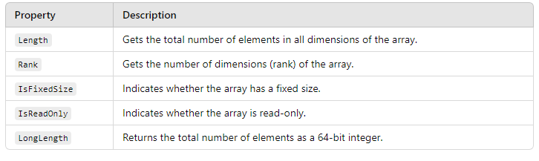

Methods of Array Class
